Ron Crites

“Country Variety Solo Artist”

E-Mail Newsletter
January 2015 | “Nashville, TN” Volume # 3 03/01/2016
Complete Schedule At  www.roncrites.com | Introduction  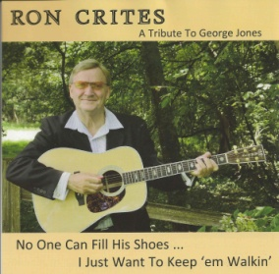  Ron is available if you need to add a fresh new act, or if you need someone to cover for one of your acts that couldn’t make the show due to unforeseen circumstances. Not just a musician, but an “Entertainer” a superb “Country Variety Music Solo Artist” He plays anything from “Traditional Country to Classic Rock & Roll” Working for the last 10 years on Carnival Cruise Lines and doing 14 contracts on 9 different ships.  His repertoire includes well over 350 songs. Ron comes complete with his own Sound & Lights  and can travel anywhere.  A little about his set up!  Performing “Live Music” with the aid of a Ketron SD3 Digital Multimedia Music Station, kicking bass foot pedals allows him to sound like a full band. He can recreate spectacular sounds of piano, brass, strings and a host of other musical instruments using a Casio MG510 Midi Guitar.  Video Samples  http://www.youtube.com/watch?v=W6pLRZToiSA “The Cold Hard Truth”—George Jones  http://www.youtube.com/watch?v=d2GEBTsa7RQ “My Baby Thinks She’s A Train”  http://www.youtube.com/watch?v=DDB8EfOcM0A “Walk Through This World With Me”  https://www.youtube.com/watch?v=HyDAHiSCLgc “Demo Of Ron Playing Live On The Ship”  I Can Do My “George Jones Tribute Show” With Just An Acoustic, Tracks or Full Band!!  http://www.georgejonestributeshow.com/  Ron plays any type of Venue!!  www.roncrites@hotmail.com  Thank you for your time!  Ron Crites 615-294-4163

